IDE Used

IDE: CLion

IDE Version: 2021.2.1

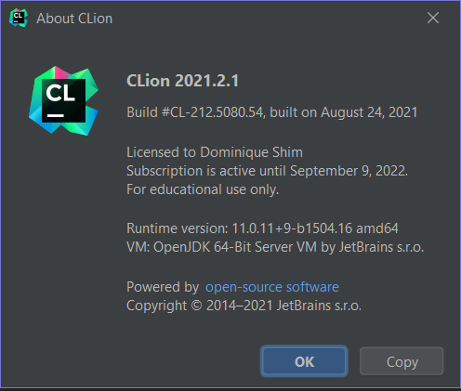

**Environment**

Environment: MinGW

Compile: G++

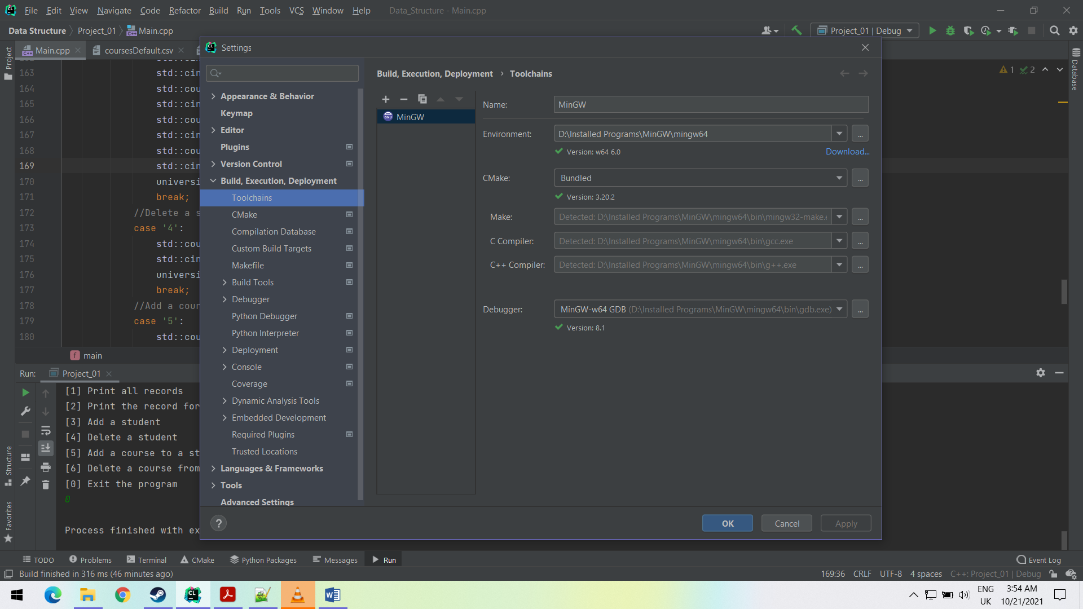

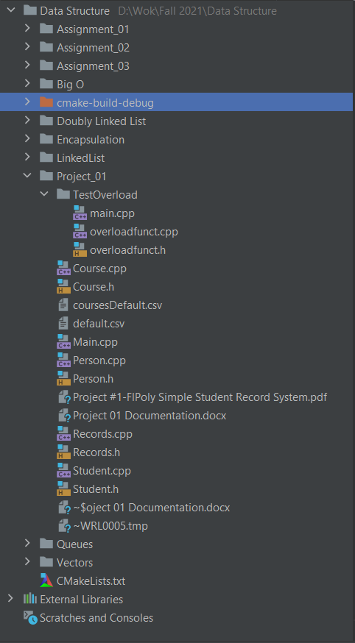**File Directory**

Note the file called “cmake-build-debug”. To load the CSV file, relative location is used from the cmake file to the CSV file must be listed.

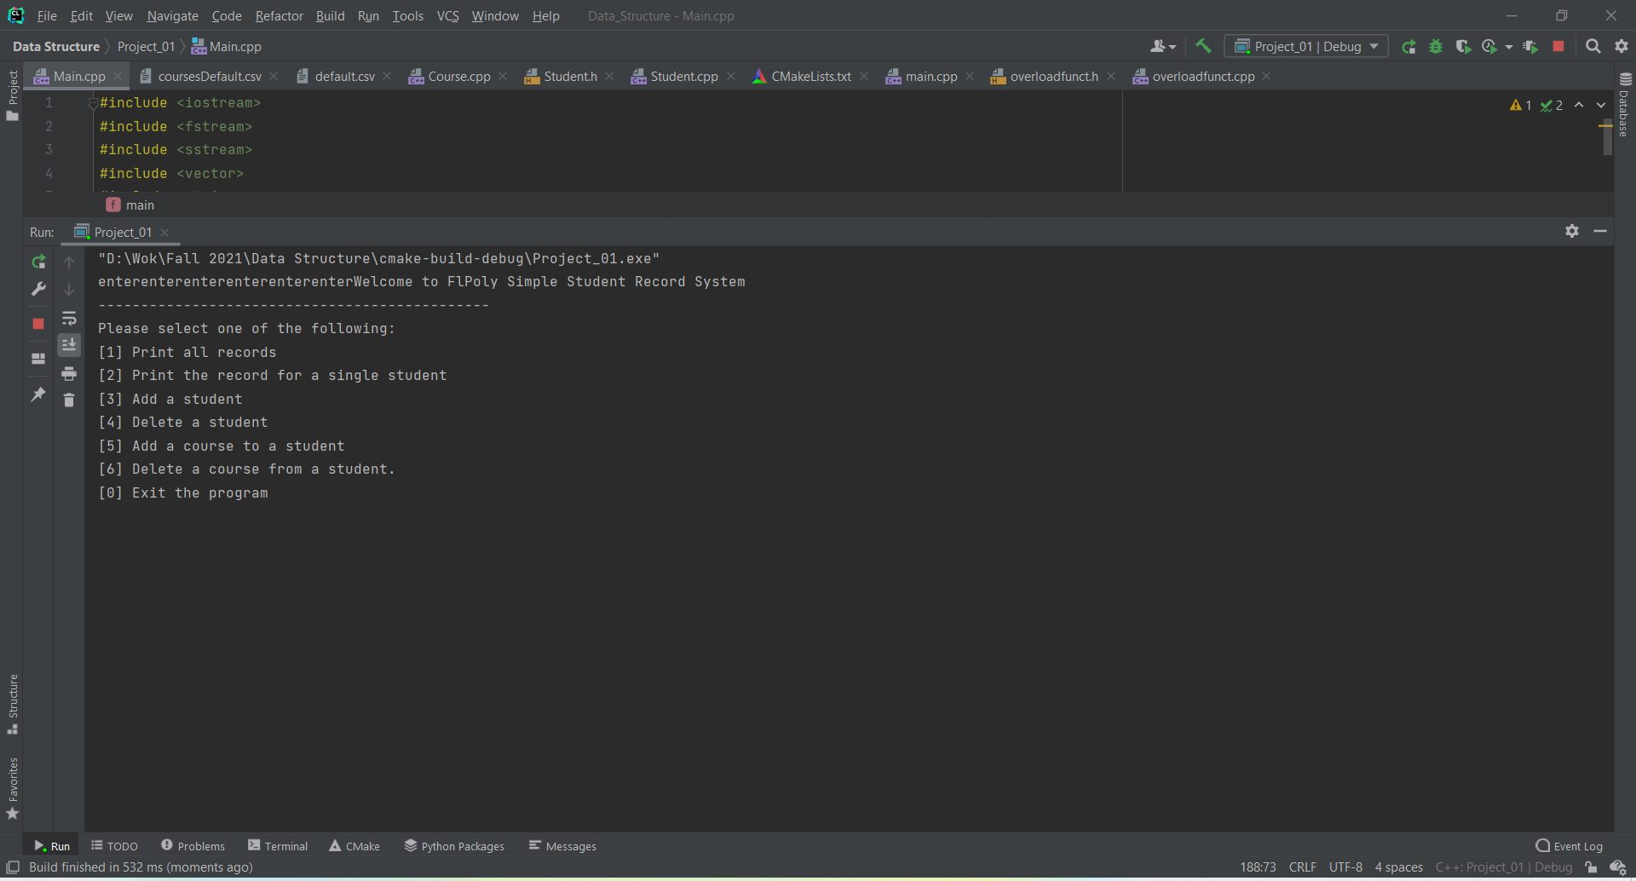**Testing**

Showing the startup of the program. It reads the CSV file and creates an object called “universityRecord”, which has five students already defined with courses.

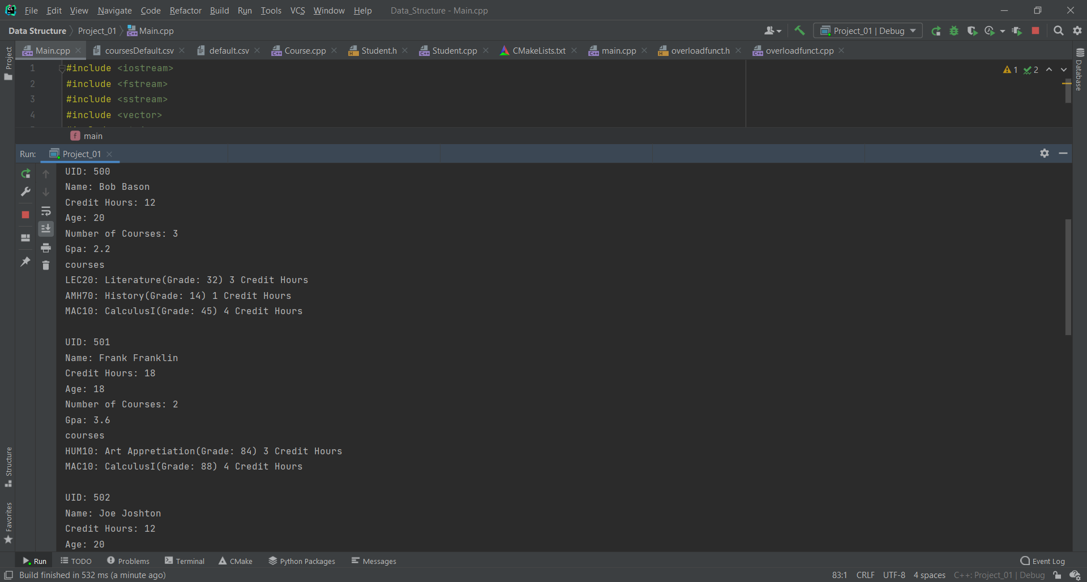Performing the first option in the program, printing all the records of the students. All five students that were taken from the CSV file was printed along with the courses they take.

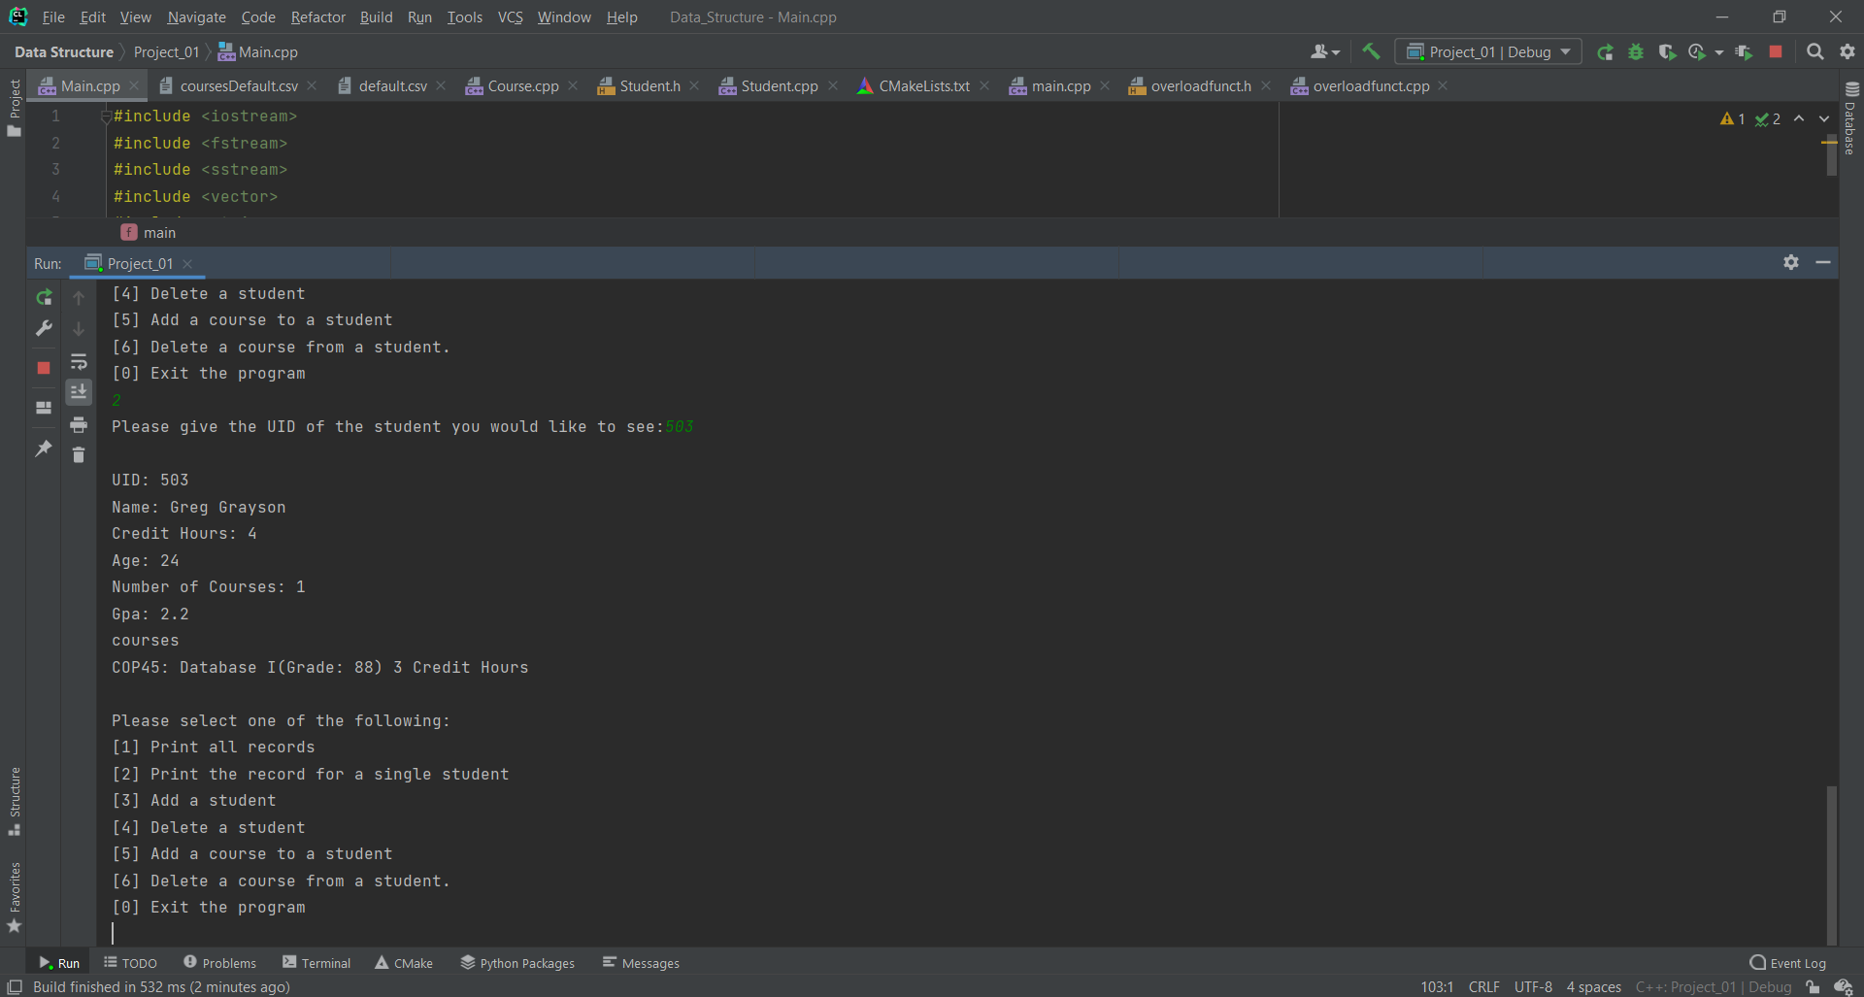

Print the record of the student with the UID of 503

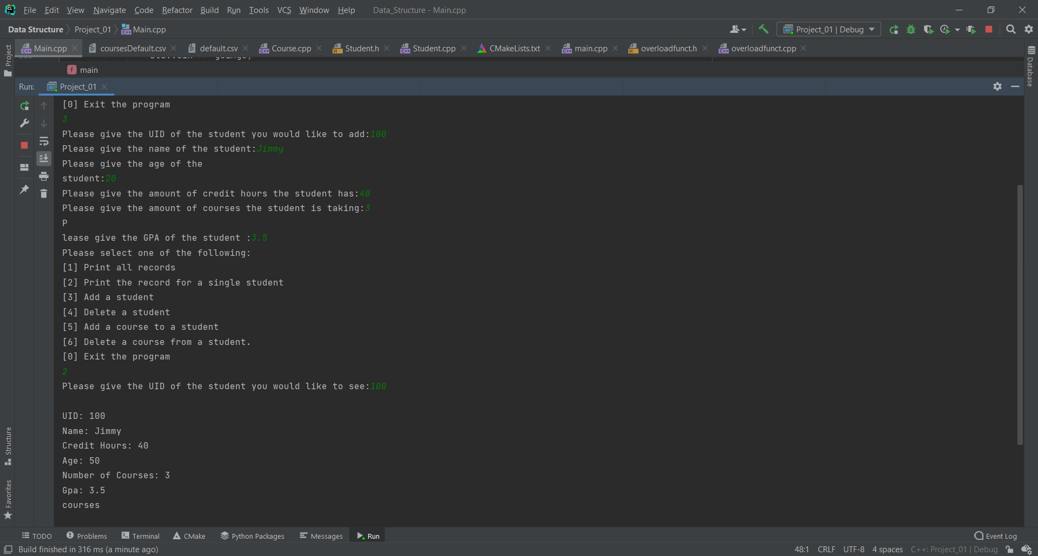A student with the UID of 100 was created and added to records. Using function two, the record of the student was printed, note that no courses are listed as none were assigned to the student.

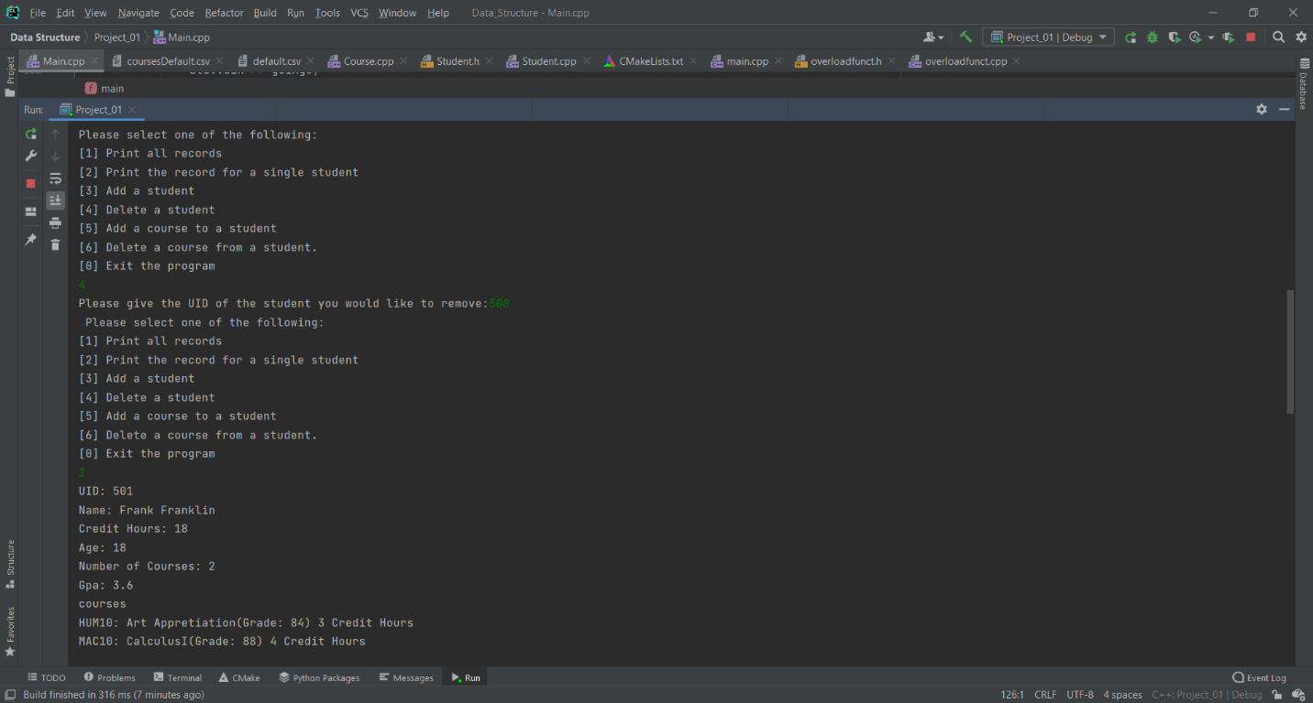Deleting the student with the UID of 500 and performing option one to print the records of all the existing students in the record.

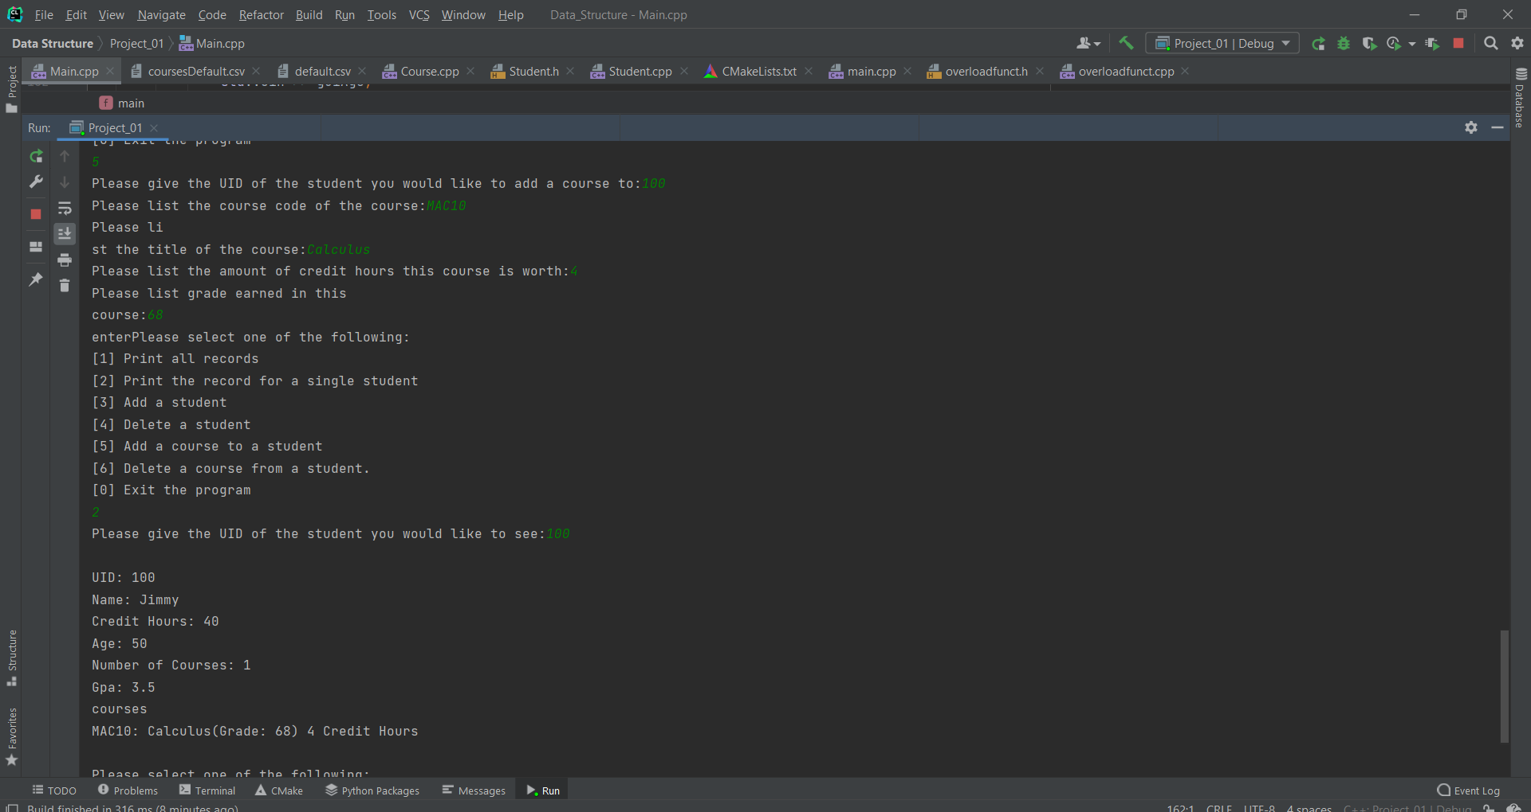Creating a course with a course code of MAC10 and giving it to the student that was previously made. Records of the student was then printed to show the newly added course.

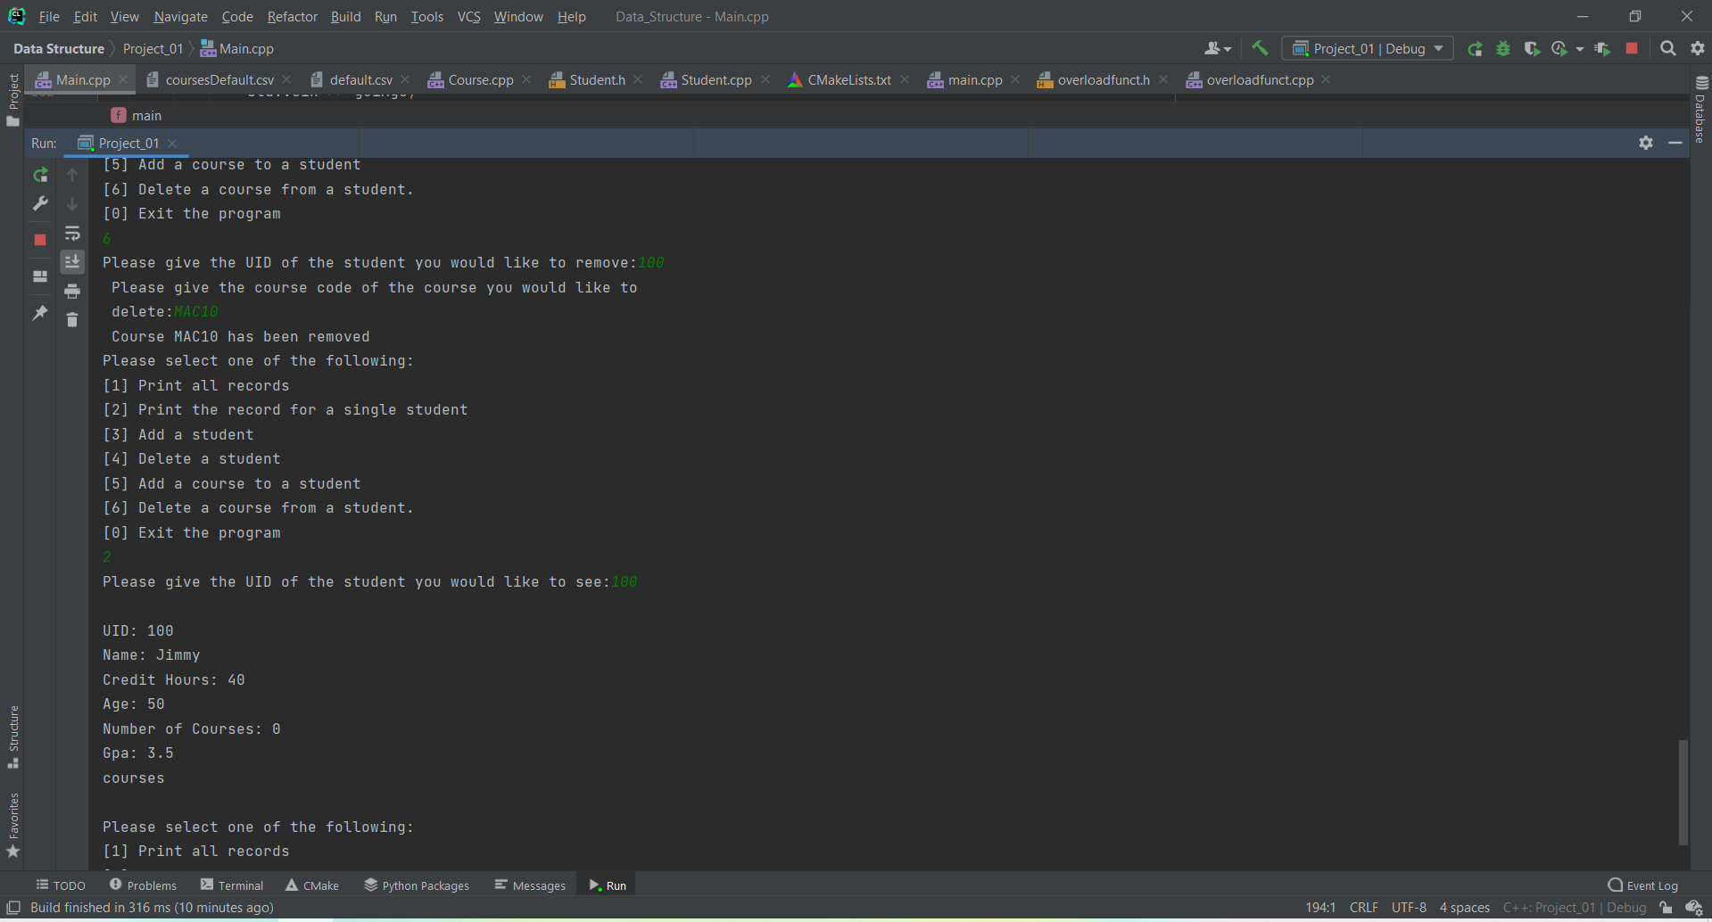

The course MAC10 that was previously added to the student with the UID of 100 was deleted. Option two was used to show the records of the student show the blank entry in courses for the student.